- As expected, the Monetary Policy Committee kept Bank Rate on hold at 4.25% this week. But both the tone of the minutes and the vote were more dovish than we had anticipated. We think an August rate cut is almost certain, with a November cut likely to follow. The MPC also seemed more open to adding an extra rate cut, if the labour market downturn deepens.
- The MPC appears to have greater conviction that the labour market is loosening and pay growth is weakening. Though the pass through to prices has been slower, this week's inflation release reported a further cooling in the Bank of England's preferred measure of services prices.
With the Bank of England's Monetary Policy Committee following a well-established pattern of cutting interest rates at alternative meetings, this week's gathering always looked likely to be low key. But while the decision to hold Bank Rate at 4.25% was predictable, the tone of the minutes and the 6-3 vote were both more dovish than we had expected.
The more dovish tone was largely driven by the BoE's analysis of recent labour market data. As we reported in last week's edition, we're now starting to get data for the period after the increases in employers' national insurance contributions and national living wage kicked in, and that data has been mostly weak. Most notably the decline in HMRC's count of payrolled employees has been accelerating and, as we had feared would happen, there have been sizeable job losses in lower paid sectors that are most exposed to the NICs and NLW increases (Chart 1). Alongside this, unfilled vacancies have continued to fall, while the net additional hours desired by workers has increased. Having been concerned about the weakness of supply in the early months of the year, the committee now feels there is "clearer evidence" that slack has emerged.
The MPC also appeared more relaxed than before about the strength of wage growth, suggesting recent settlements were consistent with the committee's view that pay growth would slow significantly over the rest of the year.
Chart 1: Early data suggests the NICs and NLW rises are hitting employment in low-paid sectors hard
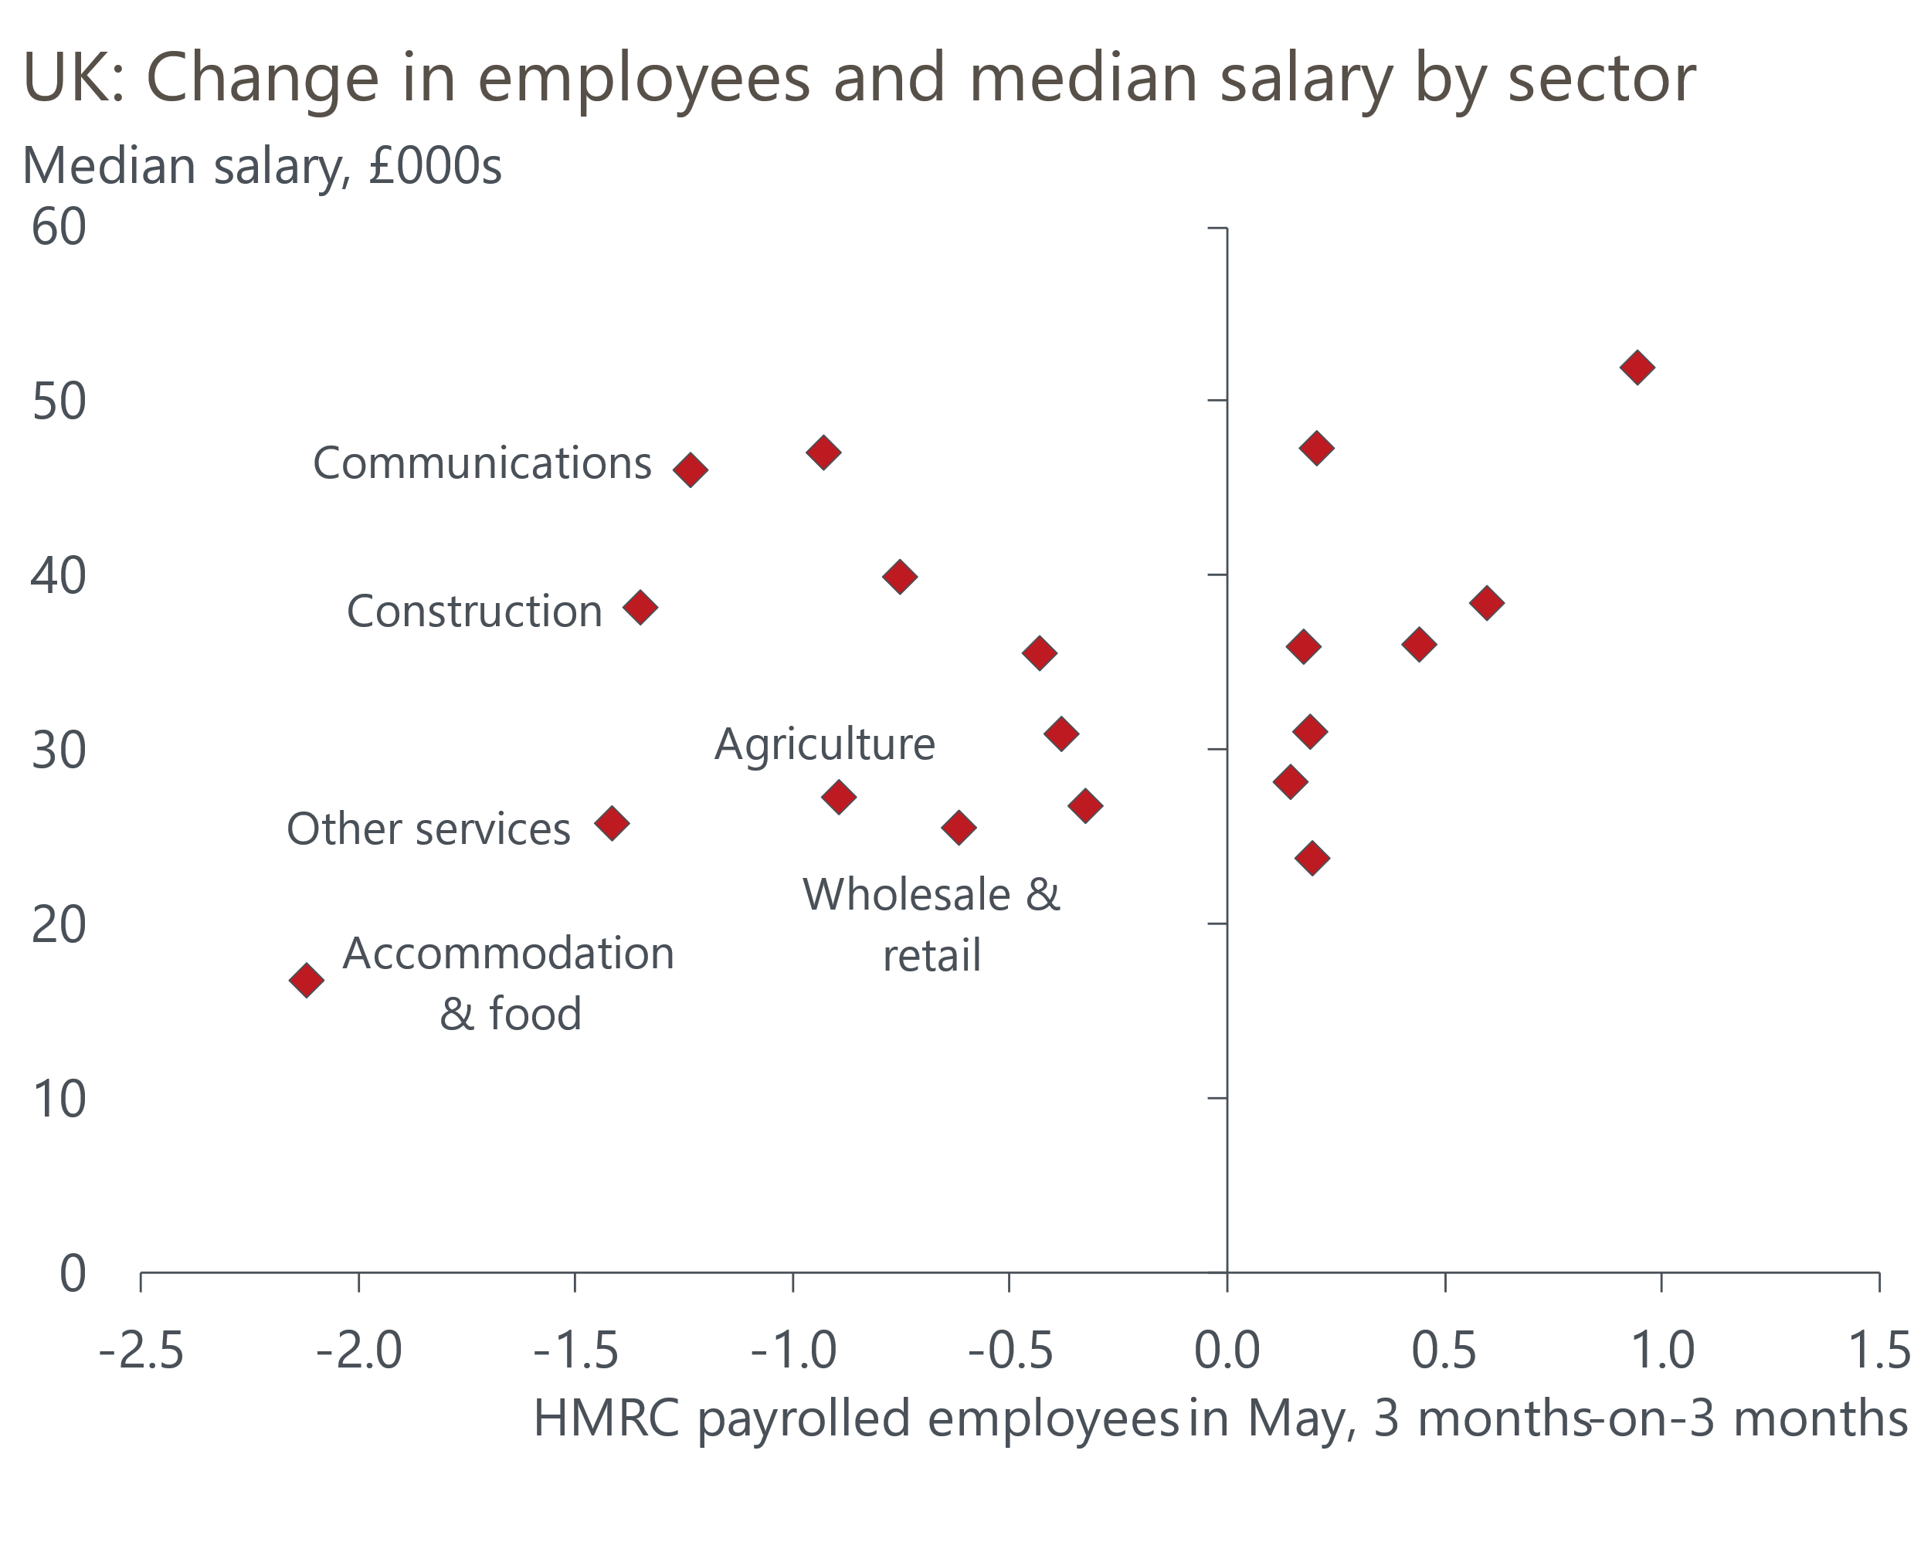
Source: Oxford Economics calculations using data from Haver Analytics & ONS

Still, the minutes made the point that greater signs of disinflationary pressure from the labour market had not yet been mirrored in domestic price-setting. CPI inflation edged down to 3.4%, from 3.5% in April, but the fall was largely due to a combination of the Office for National Statistics correcting April's error in the calculation of vehicle excise duty and the Easter-boost to air fares unwinding.
However, looking deeper into the data, there was some evidence that underlying price pressures are continuing to cool. The BoE's current favourite measure of services inflation excludes volatile elements like air fares. This series isn’t available via the ONS's monthly release, but we calculate that this measure of inflation continued its descent in May, reaching its lowest level in more than three years (Chart 2).
Chart 2: The BoE's preferred measure of inflation continued to fall in May
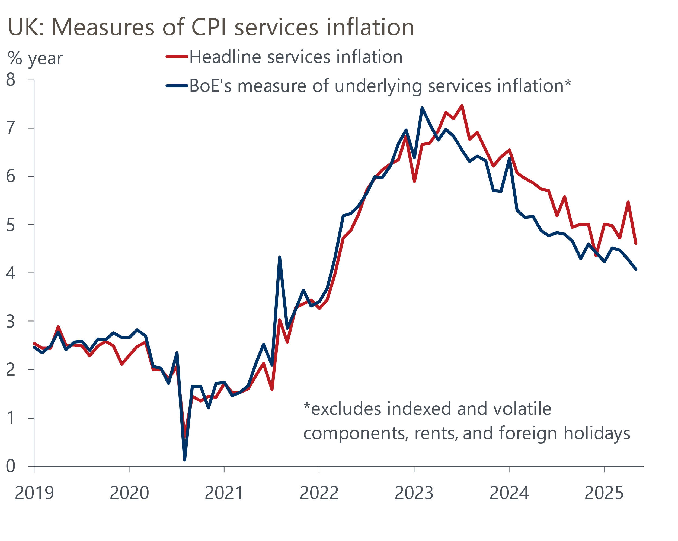
Source: Oxford Economics calculations using data from Haver Analytics
There will only be one more set of labour market and inflation data published before the August MPC meeting. Given the dovish messaging from the June minutes, it looks like it would require a major upside surprise in one of those releases to stop the MPC cutting again at the next meeting.
The bigger question now is where the committee will go from there. A 25bps cut in August would leave Bank Rate at 4%, still above the range that the MPC likely considers to be neutral. Like the MPC, we expect inflation to hover just above 3.5% over the next few months, the labour market to continue to gradually loosen, and pay growth to continue to cool steadily. If this analysis proves correct, another 25bps cut in November looks the most likely scenario, meaning Bank Rate ends 2025 at 3.75%.
But the MPC's more dovish tone and its focus on a loosening labour market suggests that the committee would be open to cutting more quickly, should the data demand it. One way this scenario could play out would be if the labour market downturn continues to deepen, with further job losses in lower paid sectors most exposed to the increases in NICs and the NLW.
A further deterioration in the growth outlook would be another potential trigger. In the minutes of June's meeting, the MPC characterised underlying GDP growth as "weak". The committee won't be particularly concerned by May's slump in retail sales – earlier data had been so implausibly strong that there was always going to be some payback at some point. But May's outturn reinforces the likelihood that we will get a much softer outturn for GDP growth in Q2 than was seen in Q1.
In the paragraph of the minutes summing up their votes, the three doves, Swati Dhingra, Alan Taylor, and Dave Ramsden, argued there was a risk that the MPC finds itself behind the curve, maintaining too restrictive a policy stance. If the incoming data draws other members into this camp, then there's a good chance that the MPC will add an extra cut in either September or December. We view this scenario as more likely than one in which the MPC skips a rate cut.

The week ahead
There's a quiet week in prospect, with just a handful of business surveys due to be published. May's S&P Global surveys saw the composite PMI edge back into positive territory, after the combination of US trade policy announcements and the implementation of the increase in employers' national insurance contributions had caused the activity balance to plunge in April. A more positive news flow on US trade policy likely created the conditions for a further modest improvement in the PMIs in June. But we see these surveys as barometers of the corporate mood rather than being reliable indicators of the strength of economic activity.
Table 1: Week ahead calendar
Date | Events | Period | Measure | Unit | Previous | Forecast
Jun 23 | S&P Global manufacturing | Jun | PMI | % bal | 46.4 | 46.6
Jun 23 | S&P Global services | Jun | PMI | % bal | 50.9 | 51.1
Jun 23 | S&P Global composite | Jun | PMI | % bal | 50.3 | 50.5
Source: Oxford Economics

Key forecasts
Table 2: UK forecast overview
(Annual percentage changes unless specified)
 | 2023 | 2024 | 2025 | 2026 | 2027 | 2028
GDP | 0.4 | 1.1 | 1.1 | 0.9 | 1.3 | 1.8
Private consumption | 0.5 | 0.6 | 1.0 | 1.2 | 1.3 | 1.7
Fixed investment | 0.3 | 1.5 | 2.0 | 0.6 | 1.6 | 2.0
Government consumption | 1.6 | 3.0 | 1.5 | 1.7 | 1.6 | 1.7
Exports of goods and services | -0.4 | -1.2 | 1.0 | -0.7 | 1.2 | 1.4
Imports of goods and services | -1.2 | 2.7 | 2.5 | -1.2 | 1.1 | 1.4
Industrial Production | -0.8 | -1.2 | 0.0 | -0.3 | 0.7 | 1.2
Consumer prices | 7.3 | 2.5 | 3.2 | 2.5 | 2.4 | 2.1
Unemployment rate (%) | 4.1 | 4.3 | 4.7 | 4.9 | 4.8 | 4.5
Current a/c balance (% of GDP) | -3.5 | -2.7 | -3.1 | -2.8 | -2.7 | -2.6
Government balance (% of GDP) | 5.2 | 5.1 | 4.3 | 3.6 | 2.9 | 2.6
Central bank policy rate (%, EOP) | 5.25 | 4.75 | 3.75 | 3.00 | 2.50 | 2.50
10yr govt. bond yield (%, EOP) | 3.54 | 4.57 | 4.50 | 3.96 | 3.44 | 3.35
Exchange rate (US$ per £, EOP) | 1.27 | 1.25 | 1.35 | 1.35 | 1.35 | 1.35
Exchange rate (euro per £, EOP) | 1.15 | 1.21 | 1.19 | 1.19 | 1.19 | 1.19
Source: Oxford Economics
Table 3: Quarterly forecasts for the UK
 | 2025 |  |  |  | 2026
 | Q1 | Q2 | Q3 | Q4 | Q1 | Q2 | Q3 | Q4
GDP (% year) | 1.3 | 0.9 | 1.1 | 1.2 | 0.7 | 0.8 | 0.9 | 1.0
CPI inflation (% year) | 2.8 | 3.4 | 3.5 | 3.2 | 3.0 | 2.2 | 2.4 | 2.5
Bank Rate (%, EOP) | 4.50 | 4.25 | 4.00 | 3.75 | 3.50 | 3.25 | 3.25 | 3.00
10yr gilt yield (%, EOP) | 4.70 | 4.70 | 4.61 | 4.50 | 4.37 | 4.24 | 4.10 | 3.96
US$ per £ (EOP) | 1.29 | 1.35 | 1.35 | 1.35 | 1.35 | 1.35 | 1.35 | 1.35
Euro per £ (EOP) | 1.20 | 1.19 | 1.19 | 1.19 | 1.19 | 1.19 | 1.19 | 1.19
Source: Oxford Economics

Latest Country Economic Forecast:
June 17, 2025

Recent publications

Data Insights
An autumn fiscal reset remains likely
May's slump in retail sales is payback for earlier strength
Inflation fell in May, after ONS corrected April's road tax error
GDP fell in April, as Q1's strength partially unwound
Labour market data suggests disinflation is on track

Research Briefings
MPC’s dovish hold boosts the chances of an August cut
MPC Preview – Divided committee to pause in June
Unconvincing spending review is another fiscal stopgap
Tough fiscal choices looming in the Autumn
What the EU deal means for trade and growth

Contacts

Oxford Economics' UK team
- Andrew Goodwin - Chief UK Economist - agoodwin@oxfordeconomics.com
- Edward Allenby - UK Economist - eallenby@oxfordeconomics.com

